Chapter 7, Solution 19.

In the circuit of Fig. 7.99, find i(t) for t > 0 if i(0) = 6 A.

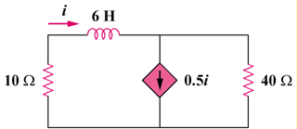

Figure 7.99
For Prob. 7.19.

Solution

i₁

i₂
+

i

i₁

i₂

1 V

i/2

10

40
To find we replace the inductor by a 1-V voltage source as shown above.
But and
i.e.

